12 Pointed Star and
the New Age Symbol

I’d like to explore with you the 12 pointed star symbol that is used in the Triangles work and its relationship to the New Age Symbol.

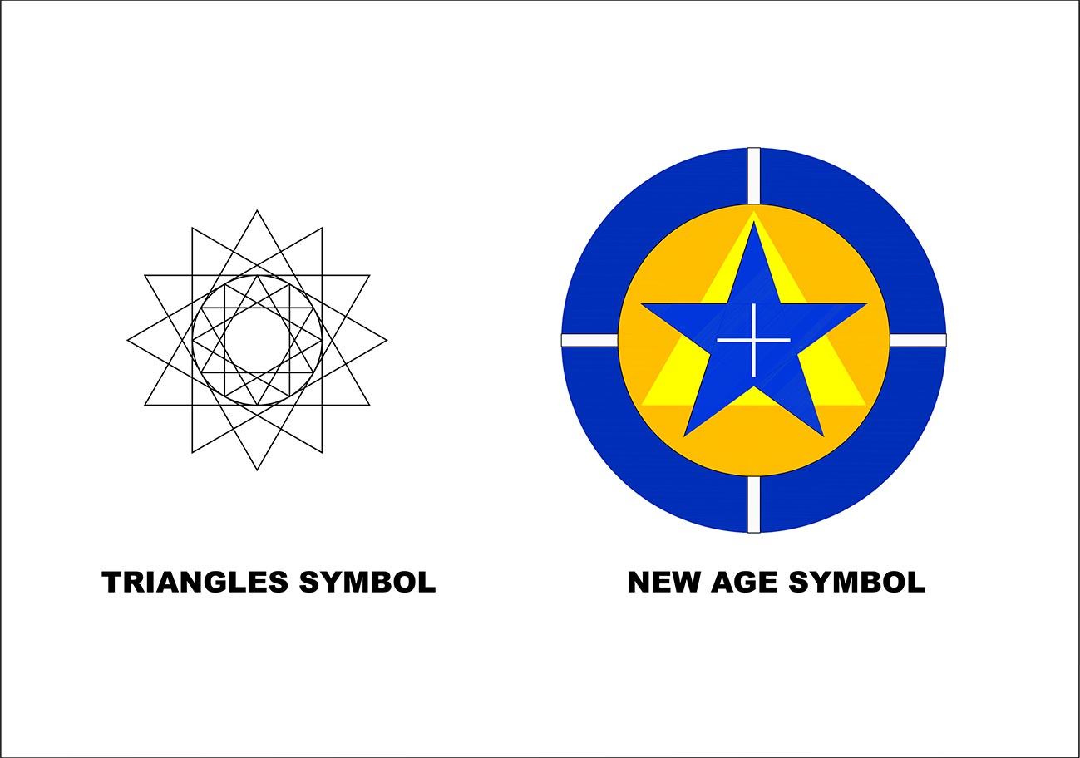

The 12 pointed star can be seen principally as a symbol to represent the quality of divine wholeness and integrity in this work we do together. It is a very stable construction of four intersecting equilateral triangles which is repeated as an inner star as well as an outer one.

An explanation of its geometric construction may help us understand its significance.
- A single circle is drawn.

- A second circle is drawn with its centre on the perimeter of the first circle.

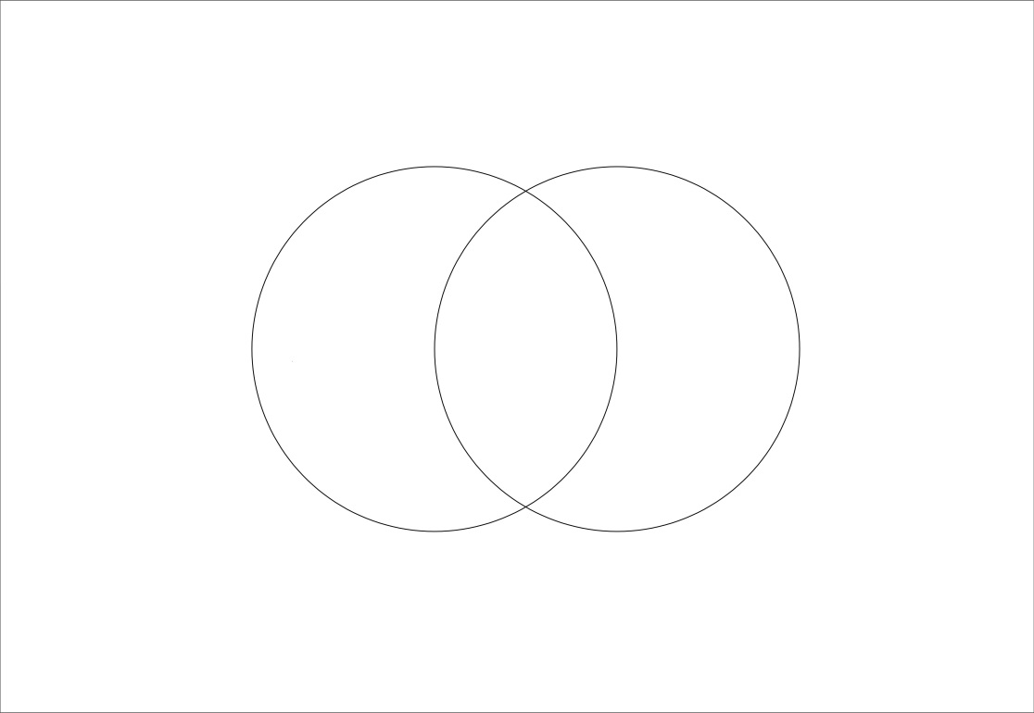

- Horizontal and vertical axes are drawn through the centres of each circle and the points of intersection between them respectively. This overlapping space is called in Latin the Vesica or Vesica Piscis as it looks a like a fish, vesica translates to vessel in english. In Christian symbolism this is the location of the mediating Christ principle, or as we may name it, the location of the Soul with the two intersecting circles symbolising Spirit and Matter.

- Two equilateral triangles can now be drawn within this space between the two circles. We can say that these two triangles are born from the womb of this Vesica or Soul space.
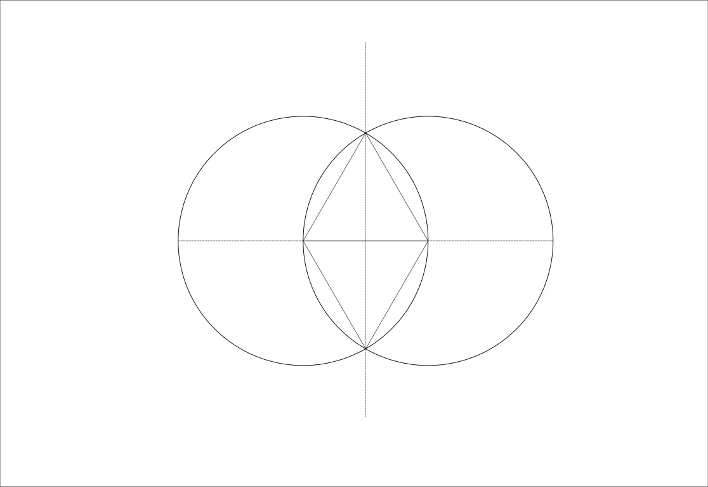

- It is interesting to note that with a very economic addition of 4 more lines we have 2 squares added to the diagram each sharing a common base line with its own triangle.

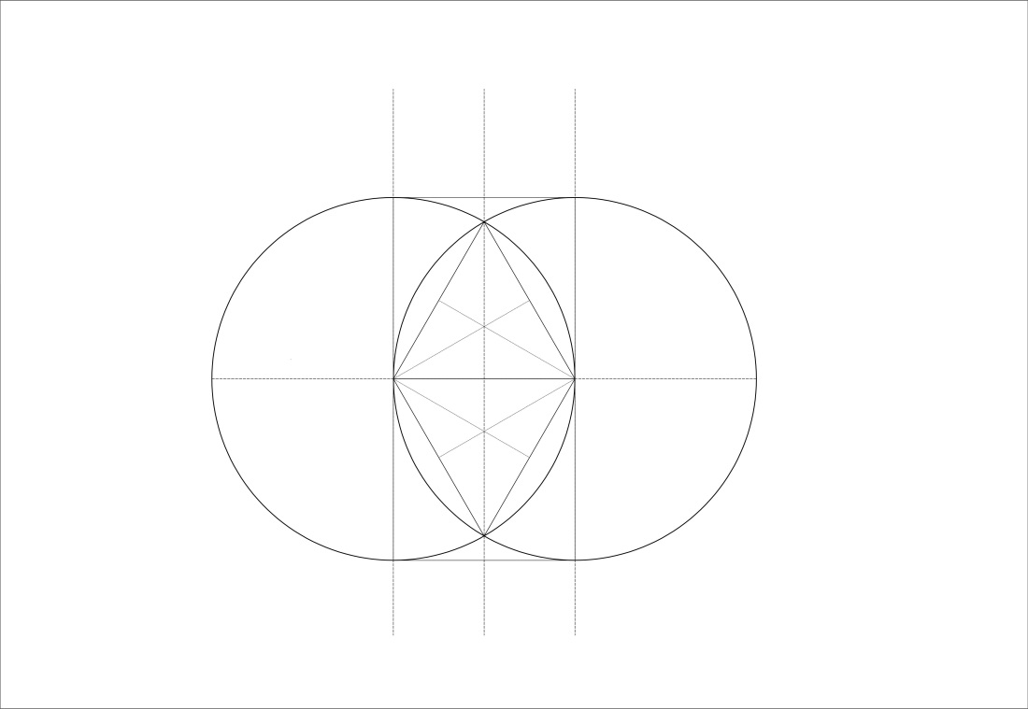

- If we identify the upward pointing triangle as representing Spirit and the downward pointing triangle as representing Matter then in this scenario we can assume that they will want to come into closer aligned relationship with each other and also with the centre of the Vesica they inhabit. Therefore they will start to move downward and upward to find the common centre.

- The destination point of this journey of these two aspects of this Life is the 6 pointed star we all know so well from Judaic and Hindu symbolism.

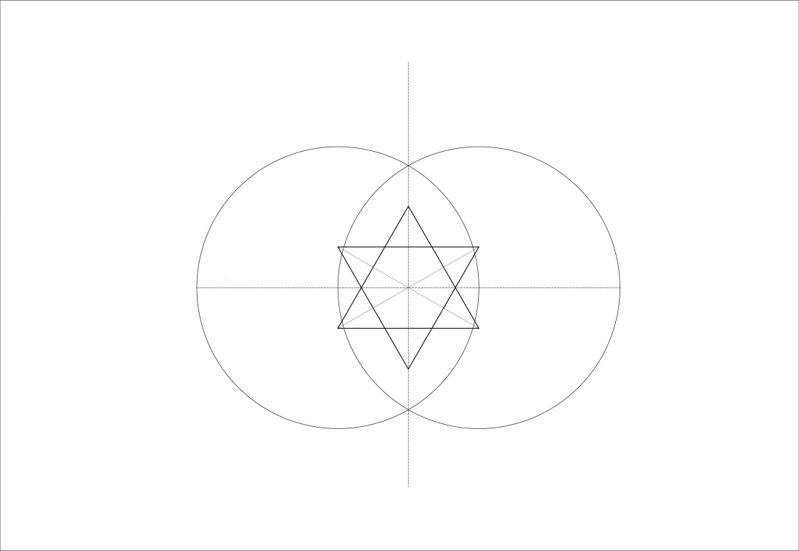

- So we have the primary relationship of Spirit, Matter and the intersecting Soul star at the centre.
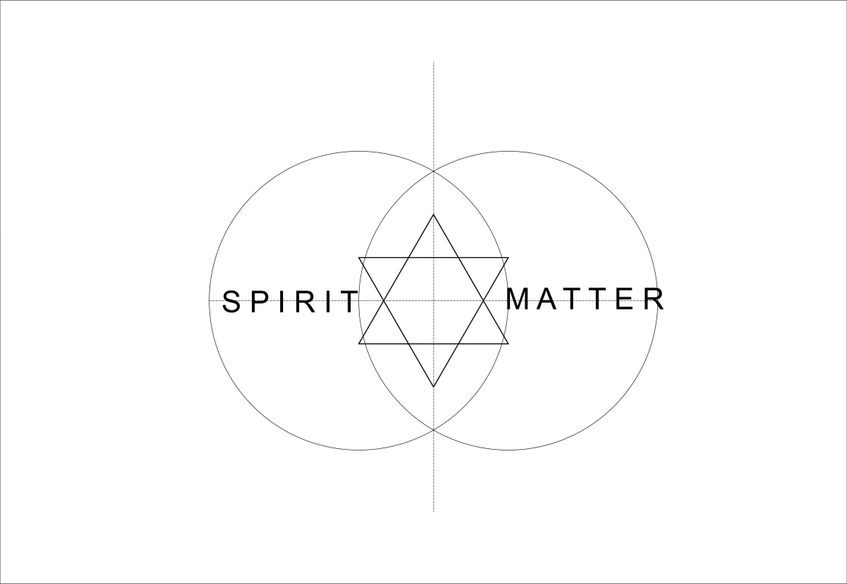

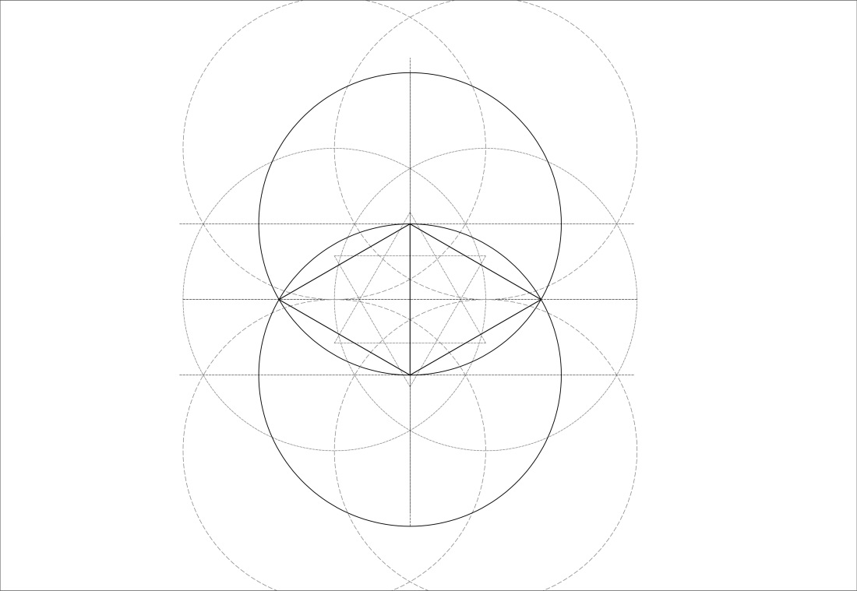
- We can now repeat this creative process by drawing two more identical circles at 90 degrees to the first two and repeating the triangulation within the corresponding Vesica.
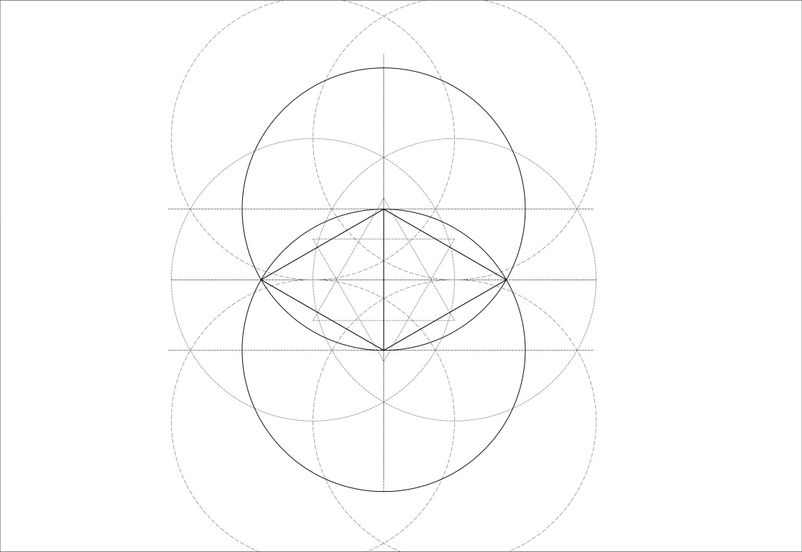

- We now have a 12 pointed star borne out of 4 equal circles. We can at this point name these 4 areas of Life which together form a human being, Spirit, Matter, Sentience and Thought. So we have a universal map of the Soul encapsulated in this diagram.

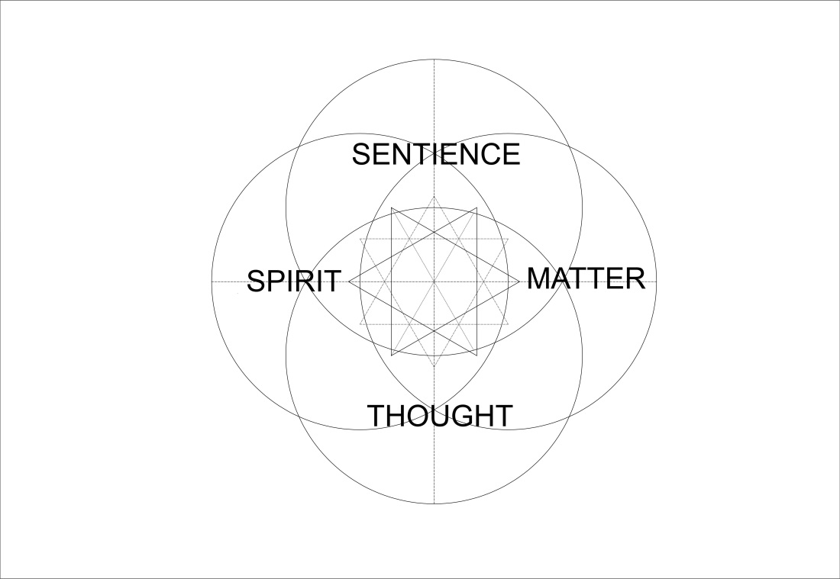
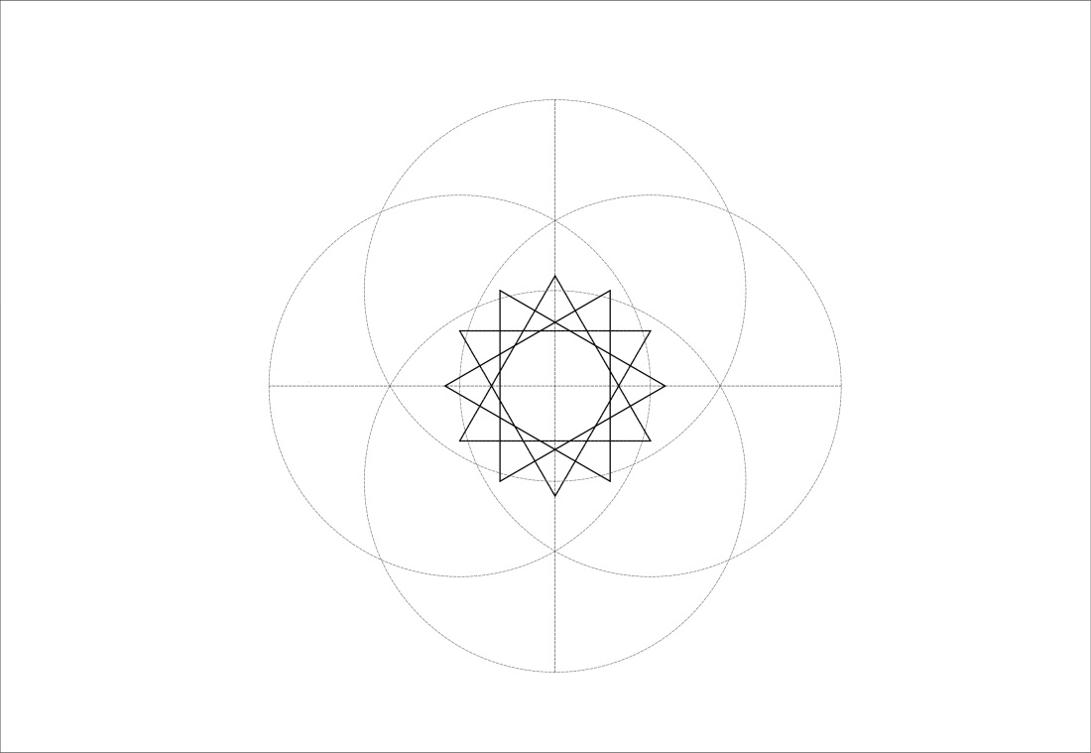

- We can now look at this symbol as an aid to meditation and alignment within the Triangles work. The stability and intersection of the lines leads the eye in towards the centre of the star and allows the mind to focus in on this point from where all the lines radiate, resting there and achieving stillness so that the higher mind or higher Self can be contacted.
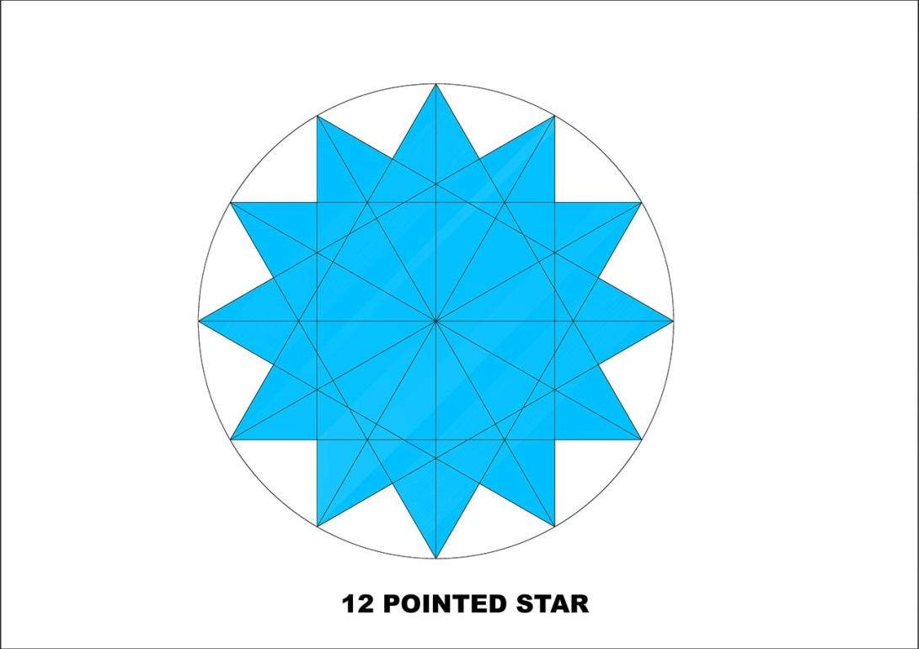
- If we imagine that this central point represents the Will aspect of God then we can hold this symbol in mind as we say the Evocation of the Will at the beginning of the Triangles meditation. “In the centre of the will of god I stand, naught shall deflect my will from his” All this said while focussing on the central point of the star.
- Then we say: “I implement that will by love” Here one shifts focus outward to become aware of the 4 surrounding intersecting triangles which symbolise the 4 fold expression of human life, 3 triangles representing the personality and the fourth central upright triangle as symbolising the Soul ‘the triangle divine’.

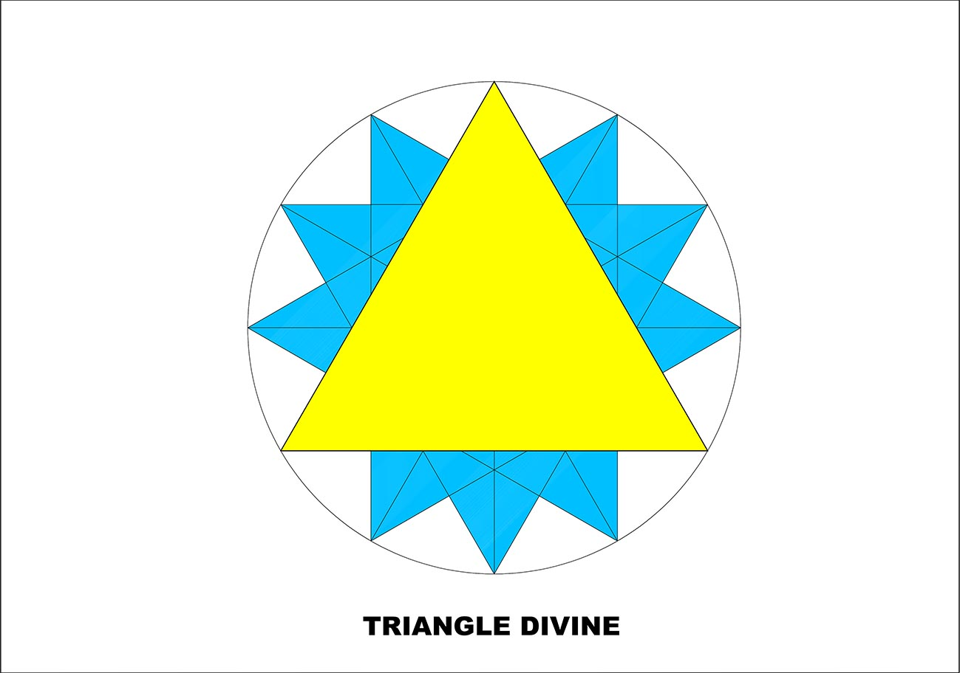
- Then we say: “I the triangle divine work out that will within the square and serve my fellow men”

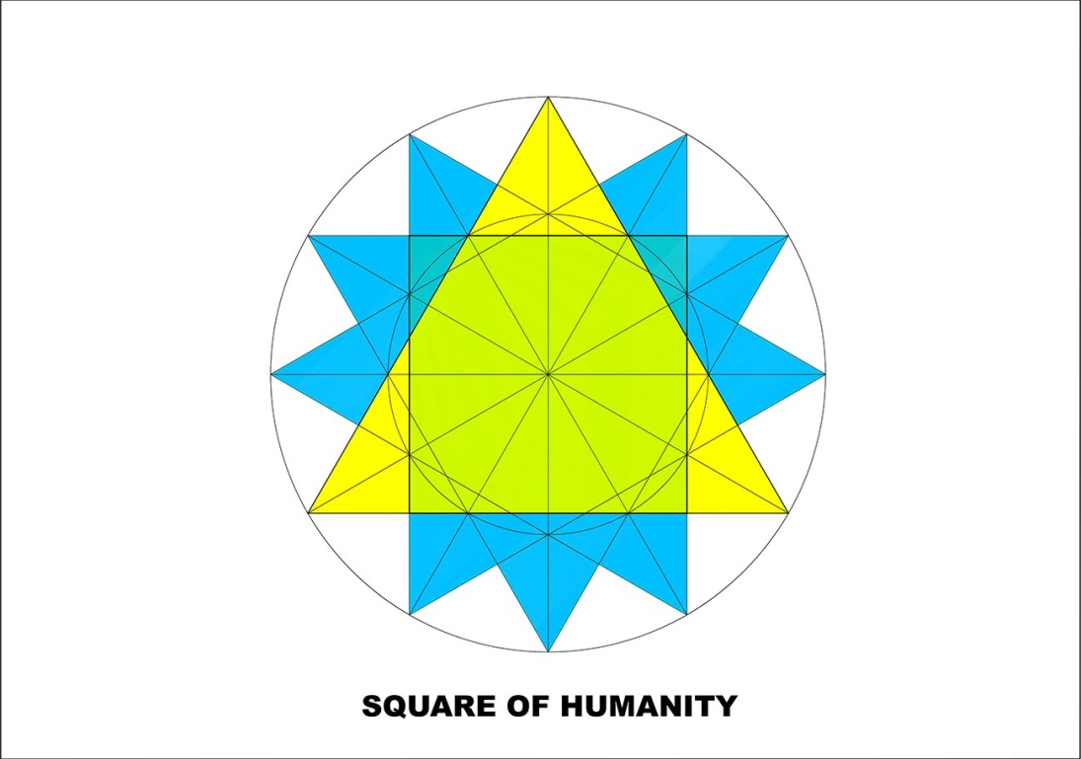
As can be seen from this diagram, the square representing Humanity is located centrally within the star and relating to the triangle of Soul which stands behind it.
So we can use this 12 pointed star as an aid in focussing our consciousness during the Triangles meditation encompassing as it does the 3 levels of consciousness with which we are working, the Spiritual Will (the central radiating point), the Soul or Love aspect (the central triangle) and the Human field of daily life (the square).
If we return to the Triangles symbol
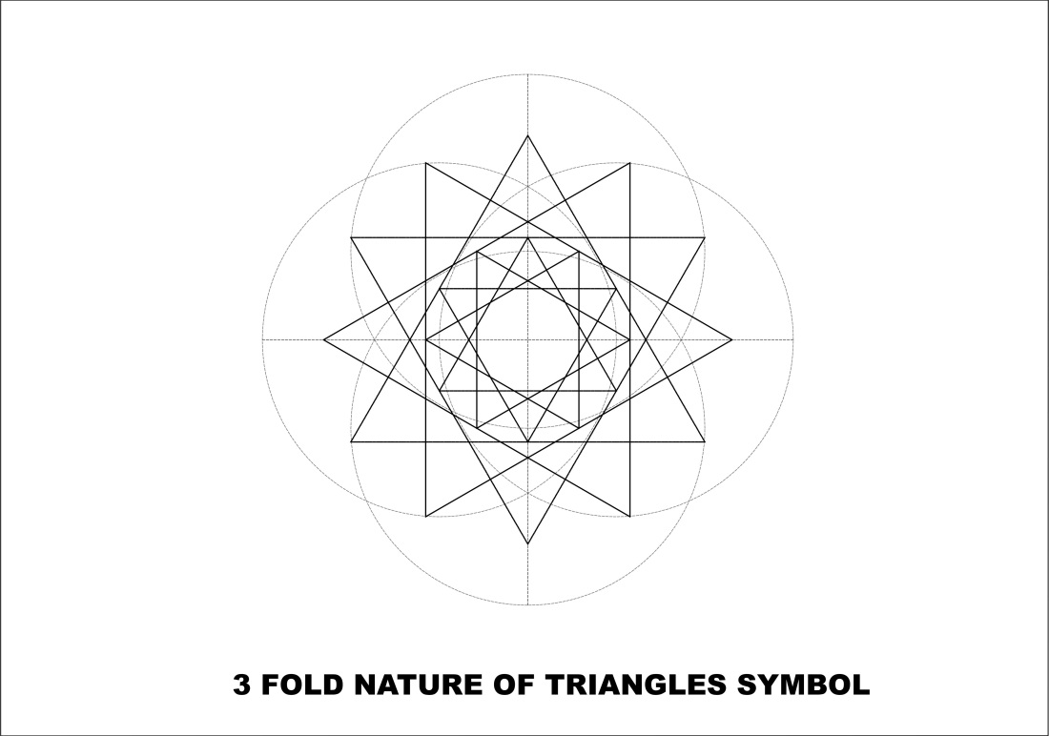

we can see that there are 2 stars, an inner and outer. The star form has fractal properties so that by the halving or doubling of its dimensions we can increase or reduce its size ad infinitum.
What is the significance of the inner star?

To answer that we need to look at the New Age Symbol and its meaning.
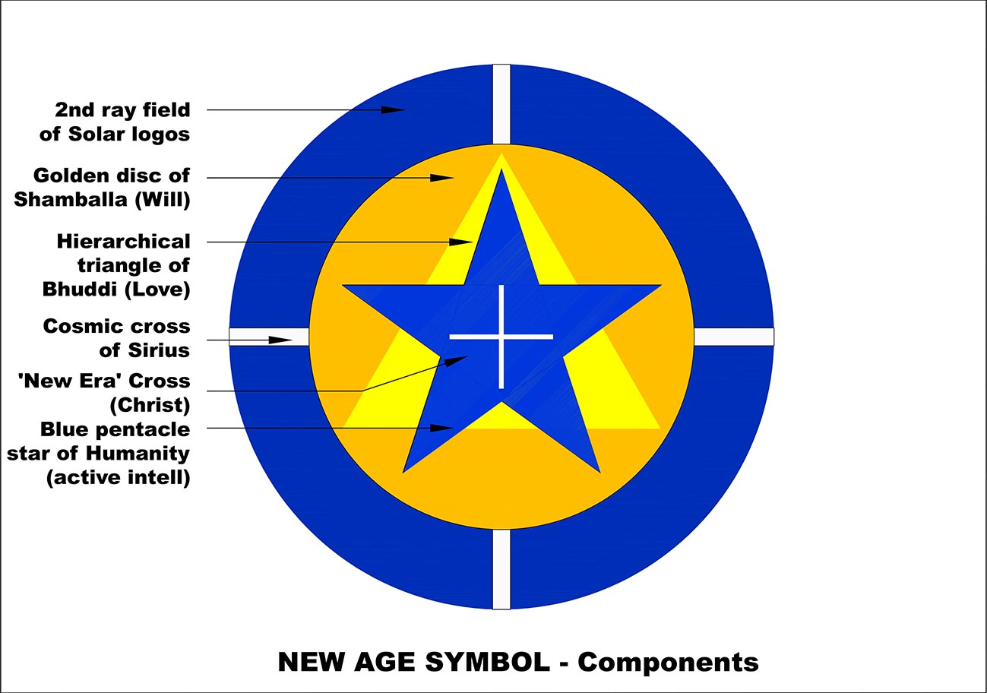

Essentially this diagram when used in meditation symbolises a number of inter related energies with which we are working to bring into being the new paradigm of the Aquarian Age.

There is an essay by Foster Bailey which explains this in detail. The Golden disc represents the Will of God, Shamballa, the yellow triangle represents the Spiritual Hierarchy of Ascended Masters and the blue pentacle star represents the highest level of consciousness Humanity as a unit can embody at this time.

The small white cross at the centre represents the equal armed cross of future Aquarian human activity where the vertical arm is our relationship to the Divine and the horizontal arm is our evolving harmonious relationships with one another.

There is balance here between these two modes of being and the Christ or Coming One, depending on your tradition, stands at the centre of this cross. He also stands as the connecting point of relationship between Humanity, Hierarchy and Shamballa.
There is an obvious relationship to the larger white cross standing behind which symbolises the spiritual energies of Sirius with which we are told our planet is connected.
If we superimpose the Triangles symbol onto the New Age Symbol we see that there are some interesting relationships between the two.

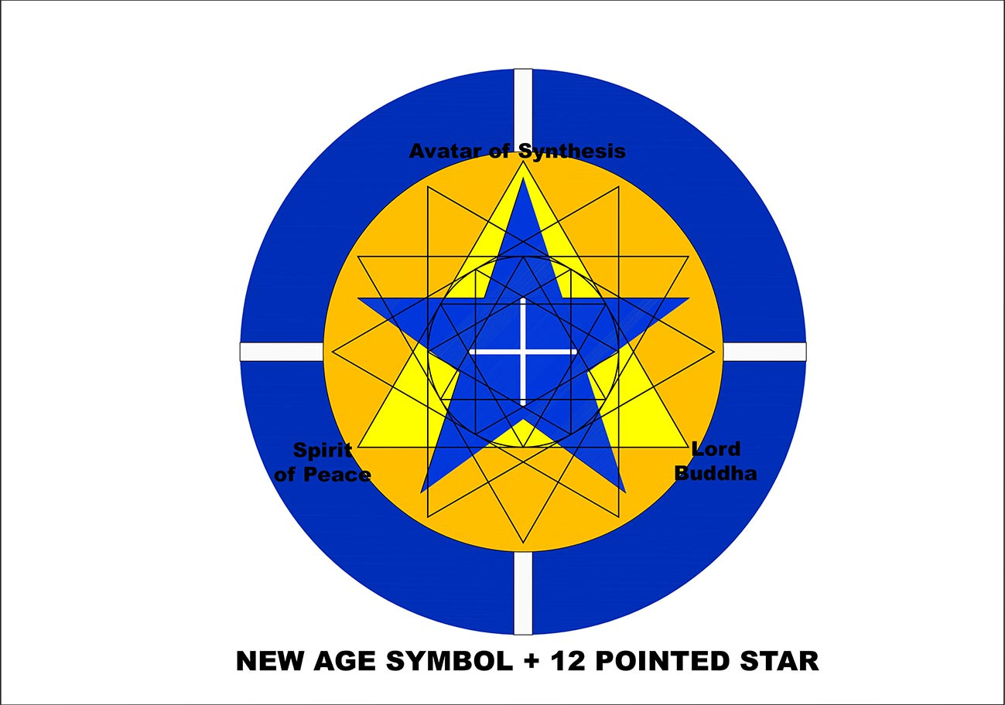

Three relationships to point out are:
- the central ‘triangle divine’ in the Triangles symbol relates geometrically in spatial terms to the yellow triangle of Hierarchy in the New Age Symbol. As we are told in Foster Bailey’s essay this yellow triangle of buddhic consciousness has 3 powerful loving intelligences at each of its corners who are helping us at this time to make the transition into the new Aquarian paradigm. The Lord Buddha, The Spirit of Peace and Equilibrium and The Avatar of Synthesis.
- the second relationship is the location of the central white cross inside the inner 12 pointed star of the Triangles symbol, relating the ideals of the coming Aquarian Age to the outer star representing our present world of human activity. So at the central point of both symbols, the centre of the Will of God and the Coming One are co located bringing us visually and symbolically an expression of co ordinated unified purpose at the centre of our planetary Life.
- the third relationship of note is in the inner square, in red, formed by the intersection of the inner star of triangles and the circle which circumscribes the central cross, the surface areas are approximately the same of these two forms. The relationship expresses an ancient relationship called the ‘squaring of the circle’,

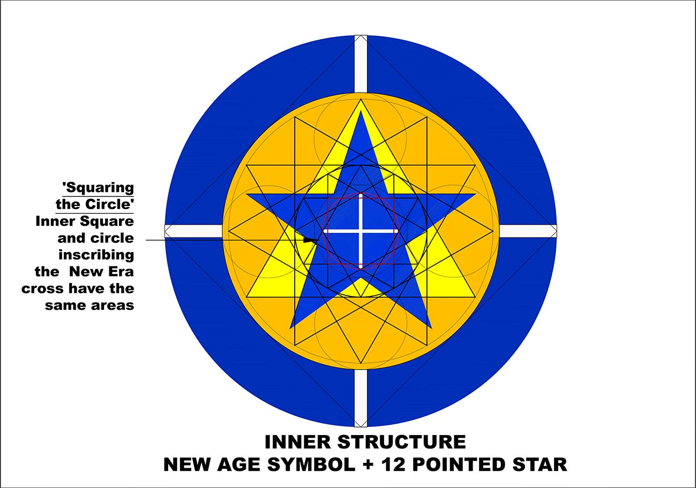

- Robert Lawlor in his book ‘Sacred Geometry’ says this ‘the circle represents pure unmanifest spirit-space, while the square represents the manifest and comprehensible world. When a near-equality is drawn between the circle and the square, the infinite is able to express its dimensions or qualities through the finite.’ This reminds us of the esoteric work of ‘linking the inner world of Light and the subtle world of glamour’

I hope this geometric exploration can contribute a little to our understanding and we can ponder on the significance of these interrelated symbols and their usefulness in the Triangles work we do together. Thank you.

James Mills

