Good afternoon. It’s a pleasure to be here discussing what the future holds.
Years ago, I was in charge of technology forecasts at what was then PriceWaterhouse. Forecasting the future for clients who depend on you is tricky business, because, despite your best efforts, you’re going to be wrong a lot of the time. One way we chose to address that uncertainty is to provide forecasts at three different levels: projections that we were pretty sure of, those that were likely to arise from the previous projections, and those that were much further out.
In 1999, when the Internet was becoming popular but the Web was still very immature, we were getting a lot of pressure from clients to forecast what effect the Internet and the Web would have. Our reply, which I think has been validated, is that the Internet would make you more of who you are. That is, if you’re a hard worker, it will allow you do more work. If you’re lazy, it’ll help you find ways to be even lazier. If you love to cook, you’ll be able to cook in ways you never thought of. And so on.
Today, we are in the same place in relation to AI that we were in 1999 with the Internet. We’re on the threshold of enormous changes and upheaval. As with the Internet, those changes will reach into every corner of our lives and businesses.
If I were pressed to make one of those safe assumptions about the effect of AI, I’d say: It will make you even more of who you are, but it will require more from you than the Internet did.
Chief among those requirements will be new responsibilities. In this presentation, I’d like to talk about responsibilities in the workplace and in the larger consumption of information in daily life. I will finish up with some tools to help work out these responsibilities. Those resources are shown in this slide deck, which will be made available later on.
In previous generations, the primary effect of change in the workplace was the replacement of physical labor by machines. In so doing, machines displaced many jobs and eliminated entire professions---almost all of which were blue-collar work; that is, manual labor in its many forms.
AI, however, is a knowledge-based phenomenon. As a result it will not only affect blue-collar jobs, but it will also make significant incursions into white collar jobs. Not just into management roles, but into the professions, as well.
Low-skill office jobs will feel the first effects—activities such as filing, summarizing reports, bookkeeping, claims processing, initial customer service, and so on will be affected. Later on, higher skilled jobs will give way to AI in a likely two-step process: initially AI will handle simple profession-specific tasks and, as AI capabilities grow, it will handle more-complicated cases that presently require human judgment.
We already see this in the health industries: AI is analyzing x-rays and medical test results and providing feedback in routine cases. These analyses will surely expand to more cases, such that radiologists will be needed only for difficult or exceptional x-rays. That is, far fewer radiologists will be needed.
So, while AI will indeed threaten many white-collar jobs. If you have such a job, you owe it to yourself to recognize the threat and to adapt accordingly. Specifically, how?
For most employees, the movement of AI up the value chain will require that they continue to acquire new skills and move up the value chain in parallel. The present white-collar mindset, in which employees attend to their skills only a few hours a year in the form of “continuing education,” will need to change and employees who want to remain employed will have topush themselves into progressively more advanced skillsets. Standing pat will no longer work.
I wish to point out that this kind of professional self-development has always been a recommended practice. Now, however, it will become mandatory. This topic of known best practices now becoming essential is a theme I will touch on again later on.
A second important responsibility is to keep up to date on what is happening in your industry, particularly as regards the use of AI. You want to make sure you’re not falling behind. One of the best ways to do this is to embrace AI in your workplace. Become a leader in learning how to use it. Learn and then teach others. You want to be the radiologist who is making the hospital more responsive to patients by using AI—he or she will have a job.
Encourage colleagues to do the same. If you’re a manager, then encourage self-development by making it easier for employees to invest in themselves—this responsibility will become an important part of your job, if you want to retain employees and have them contribute intelligently to you work.
Allow me a side note: it’s tempting to think that employees whose jobs are dislocated can fall back on retraining. However, retraining has a very mixed record. Low-skilled employees, especially older ones, frequently don’t have the capacity to learn new and different skills, even if they can afford the cost in terms of time and money. As detailed in the book Janesville, which analyzed what happened in Janesville, WI when the town’s largest employer closed—employees who retrained fared the worst of all the groups; worse than, for example, those who went on unemployment for several years waiting for the plant to reopen. Employees who successfully completed retraining (a small fraction of those who set out to do this) found themselves to be too old to get entry-level jobs in their new profession and those that could get those jobs found great difficulty making ends meet on the entry-level salary. So, when encouraging colleagues or employees to build their skills, discourage the thinking that they can just “get another job.” For most of them, that’s likely to be far more difficult than they expect and in many cases, impossible.
.. .. ..
The second area of responsibility derives from the ability of AI to create illusion, to make the untrue seem to be true. I’ll be focusing on this issue in its various forms in the rest of this talk
Because AI works not with mechanical forces, but words, images, videos, and ideas it can be used in many ways to hide or distort the reality by making one thing appear as another, and so dupe honest people who are not alert to the possible deceptions. (This is similar to learning to spot spam in email.)
This kind of deception is already happening in academia in the form of plagiarism: students turn in well-written essays that were entirely created by AI. If you’d like to see this in action, go to https://chat.openai.com/ and type in “I need 1500 words on why Louis XVI was guillotined.” In less than 20 seconds, you’ll have an articulate essay on this topic.
To give you an illustration of the high quality of this generated text, here is a paragraph chosen at random from the essay that was produced when I made the previous request:
“As the situation deteriorated, the Estates-General was convened in 1789 to address the crisis. However, the Third Estate, representing the commoners, broke away from the Estates-General and established the National Assembly, signaling the beginning of the Revolution. This event, along with the storming of the Bastille on July 14, 1789, marked a significant shift in power dynamics and set off a chain of events that led to the fall of the monarchy.”
I think you’d agree that for a high-school student or an underclassman in college, an essay written at this level would certainly earn high marks. Teachers then are on the front line of the problem of distinguishing what’s real. And they are very much struggling with the problem.
While plagiarism might not seem like an important problem outside of academia, the use of falsified images and videos certainly is.
Images are often falsified. Manipulating images is a feat that goes back decades. I think at one time or another we’ve all seen or read about the images of the Soviet politburo under Stalin, in which over the years minsters who had fallen out of Stalin’s favor were removed from the photos.
Today, pictures are routinely doctored. The low-hanging fruit in changing images is modify text on signs, tee-shirts, placards, and so on. So if you see a photo that’s presented to arouse emotions of outrage, anger, elation, or surprise, be suspicious of them, especially when they contain text.
Often, however, photos are simply borrowed from one context and claimed to be from a different one. If you go to the fact-checking site snopes.com, you’ll see many examples of war footage that is from one conflict being repurposed for another. Sometimes, the repurposing is a genuine error—but in such cases, such as in the following photo, which is of firefighters in New Zealand, but repurposed as Ukrainian firemen—the person posting it did not do the minimal checking before posting it.
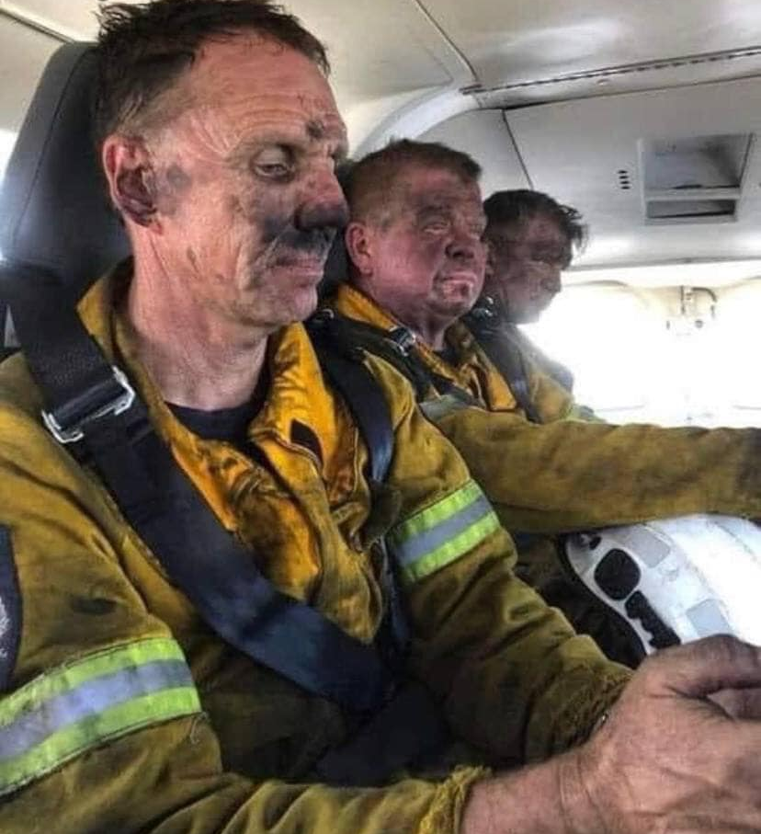
Don’t be that person. Images, in particular, are easy to check for authenticity and right attribution. I’ll discuss that shortly.
---slide 6---
A more dangerous problem is known as “deep fakes,” in which a video, has been transformed so that it appears that something else is actually happening or the participants are different. To show how subtle this can be, I’ve lined up a clip in of an entertainer who does impersonations in his appearance on TV in the David Letterman show. In the clip, he’s impersonating Tom Cruise. Later, someone took the clip and added a deep fake dimension to it, which you’ll see whenever the impersonator—who doesn’t much look like Tom Cruise—briefly becomes Cruise, whenever he quotes him. The clip starts as the impersonator is recounting his first meeting with Tom Cruise on a movie set.
https://www.youtube.com/watch?v=VWrhRBb-1Ig&t=74s
Did you see how subtle that was?
Now that you know what we’re dealing with, let’s look at another Tom Cruise clip. I ask you to see whether you can tell whether it’s really Tom Cruise or a deep fake. In this clip, Cruise is discussing the last time he met Mikhail Gorbachev.
https://www.youtube.com/watch?v=iyiOVUbsPcM
That entire clip is a deep fake. Tom Cruise had nothing to do with it and was never in any video clip similar to that.
Before diving into this topic, I should point out that just like image manipulation, the technology is not new. Movie studios have used this kind of software for years. If you remember the 1994 movie in which Forrest Gump meets US President Lyndon Johnson, you saw deep fake technology at work. What’s different today is that AI technologies have made it very simple for anyone to create the same effects. And, of course, many of the first applications of it have been less than honorable and they signal the kind of trouble we can see in the future.
For example, a recent video showed President Zelensky of Ukraine announcing a cease-fire and telling Ukrainian soldiers to lay down their weapons.
The problem of the difficulty of distinguishing the real from the unreal has three very serious effects.
- The first obvious one is that it will become increasingly hard to determine what is true. This will cause great confusion and lead people to take actions they might not otherwise take.
- It will overwhelm people to the point where they will stop making the effort do distinguish true from untrue and will simply opt to believe what they’re told. This dynamic is already visible with populist politicians, who will invent their own “facts,” knowing that many won’t believe them, but that enough people will simply accept them because they’re not sure if they’re true and they don’t have the resources or inclination to find out.
- It will enable culpable people to evade responsibility by asserting that evidence against them has been made up or created by others.
All three repercussions are serious issues.
Well, this has gotten pretty dark, hasn’t it? I suggest we look at Marx Brothers clip, which encapsulates the entire problem in a way only Groucho Marx can do. This scene comes from the 1934 movie, Duck Soup.
https://www.youtube.com/watch?v=cHxGUe1cjzM
I expect the question, “Who are you going to believe? Me or your own eyes?” will no longer be funny and, in fact, will become a crucial question to address.
So what are the responsibilities of the individual? First and foremost is to recognize what is true. The second major responsibility is to avoid spreading what is untrue.
Let’s start with the first task: getting true information. Here is a toolkit of current best practices.
News. Get your news from sites that fulfill two requirements: 1) they fact-check stories before publication, and 2) they print prompt, detailed corrections to stories. For most news, this means large, well-established media outlets. There are such outlets across the entire political spectrum.
As you likely know, news sites you subscribe to will modify the stories you’re shown based on your profile: the stories you’ve read before and the ones you’ve ignored. This tends to increase our news bubbles by not showing stories you’re known to avoid. The best way to avoid this is to get an actual hard copy of the newspaper or magazine. Flipping through one, your eye will fall on stories you might otherwise not have seen.
Facts and claims. These can be checked quickly at snopes.com or factcheck.org. I suggest putting these sites on your browser’s favorites bar and using them frequently, especially as we head into the election year in the US, where many claims will be made and need fact-checking.
Whenever a claim is made that should be factually checked, there should be some attributed source. Facts presented without attribution should immediately flag your suspicions. As much as possible, go to the original sources. If the source is some group you’ve never heard of, check them before citing the facts. Many highly political groups choose virtuous-sounding names that have little to do with their real mission. If it helps, think of the Democratic People’s Republic of Korea, which is the official English name of North Korea. You will note that every word is wrong: it’s not democratic, it’s not a republic, it wasn’t based on the will of the people, and it only represents half of Korea.
For images, you can right click on the image and copy the link. You can then paste it into the site at tineye.com. There you’ll see all the instances of this image that tineye has found on the Web. You can see them listed in reverse alphabetical order, which shows you the oldest instance of the image first. That is how I found out that the firemen in the previous image were working in Tasmania, not in Hawaii, and not in Ukraine.
Videos are still problematic. However, you can often use a search engine to see whether any site has determined whether a clip is fake.
As I mentioned earlier, the use of these tools has been a recommended practice, especially for researchers and journalists. Now, this practice will need to become an integral part of how you see the world.
Now that we’ve covered some ways to discern reality, what responsibility does that entail?
Mark Twain once observed, “A lie can travel half way around the world while the truth is putting on its shoes.” It is going to be very important to not be part of lies’ rapid travel and to be faster at helping truth put on its shoes. How do we avoid helping a lie travel?
The very first thing is not to share content whose veracity you don’t know. Not on social media, not on email, not in spoken word. This seems like an obvious thing, until some unusual piece of information comes our way that happens to fit our preferred narrative, then we want to share it with everyone. For example, this image, which recently started appearing on Facebook and elsewhere.
When you see this image for the first time, it likely stirs outrage, or a feeling of “Damn right!,” and many similar emotions.
Feeling any of those emotions must convey to you that your responsibility to withhold sharing this image until you know whether it’s true. The more the outrage, the more your resistance to sharing should increase.
As I mentioned at the beginning, the age of AI will bring wonderful developments, but it will impose a series of disciplines on thinking people of the world: a need to improve their skills in the workplace and a need to improve discernment in all other areas, especially online.
The latter requires effort and, like you, there are many times when I and others would like to share something without having to verify sources and check details. Careless sharing of this kind as well as intentional sharing by bad actors is how lies get halfway around the world so quickly.
In such cases, individual responsibility would suggest silence. “Nothing is often the right thing to do, and always a clever thing to say” the historian Will Durant once wrote.
I know that very few sessions today are quite as dark, and fewer yet are enhanced with the Marx Brothers and Tom Cruise, but I hope this has been helpful. Thank you!

